Asset Pricing Implications of Climate Risk

[Author name(s), first M. surname, omit titles and qualifications]

[Institutional affiliation(s)]

Author Note

[Include any grant/funding information and a complete correspondence address.]

Table of Contents

Abstract 3

[Title here, up to 12 words, on one to two lines] 4

[Heading 1] 4

[Heading 2] 4

[Heading 3] 4

References 5

Footnotes 6

Tables 7

Figures 8

Abstract

[The abstract should be one paragraph of between 150 and 250 words. It is not indented. Section titles, such as the word Abstract above, are not considered headings so they don’t use bold heading format. Instead, use the Section Title style. This style automatically starts your section on a new page, so you don’t have to add page breaks. To apply any text style in this document with just a tap, have a look at Styles on the Home tab of the ribbon.]

Keywords: [Tap here to add keywords.]

Asset Pricing Implications of Climate Risk

In the modern age, climate change is an important phenomenon that has emerged and captivated the attention of the scientific community. Principally, the interest is with whether humans activity has contributed to significant and meaningful change to the climate system, especially since the industrial revolution. Following robust and pertinent analysis, the scientific community has solidly reached the consensus that this is indeed the case. Paris, etc, submits COP26. In finance, this has lead to an impact in companies and therefore their sourcing of capital. This breaks down into transition risk and physical risk. Transition risk is primarily concerned with the implications and financial impacts as the broader economy shifts to a low carbon future. This primarily consists of policy & legal, technological, market and reputational risk. On the other hand, physical risk pertains to the financial implications when the effects of climate change have actually manifested. For example, with the operational disruptions that result from the extreme weather events that arise out of climate change. In our research, we strive to explore S&P and Trucost data to determine the statistical significance and economic magnitudes of the relationship between climate risks and equity returns. This will be conducted at the global scale.

# [Heading 1]

Carbon intensity has a key issue in the fact that in that it still allows for total carbon levels to increase, which is not in line with neutralizing carbon emissions so that the progression of climate change does not continue. Otherwise, we could end up with a world with significant improvements in carbon intensity yet actual and important climate change targets (e.g. < 2C increase) that are exceeded.

## [Heading 2]1

[To update the table of contents (TOC), apply the appropriate heading style to just the heading text at the start of a paragraph and it will appear in your TOC. To do this, select the text for your heading. Then apply the style you need.]

[Heading 3]. [Include a full stop at the end of a run-in heading. Note that you can include consecutive paragraphs with their own headings, where appropriate.]

[Heading 4]. [When using headings, don’t skip levels. If you need a heading 3, 4 or 5 with no text following it before the next heading, just add a full stop at the end of the heading, then start a new paragraph for the subheading and its text.] (Surname, Year)

[Heading 5]. [Like all sections of your paper, references start on their own page, as shown on the page that follows. The body of the References section uses the Bibliography style. For more detailed information on formatting references, see the APA Style Manual, 6th Edition. (Surname, Year)

References

Surname, F. M. (Year). Article Title. *Journal Title*, Pages From-To.

Surname, F. M. (Year). *Book Title.* City Name: Publisher Name.

Footnotes

1[Add footnotes, if any, on their own page following the references. For APA formatting requirements, it’s easy to just type your own footnote references and notes. To format a footnote reference, select the number, then apply the Footnote Reference. The body of a footnote, such as this example, uses the Normal text style. (Note: If you delete this sample footnote, don’t forget to delete its in-text reference as well.)]

Tables

Table 1

[Table Title]

|  |  |  |  |  |
| --- | --- | --- | --- | --- |
| Column Head | Column Head | Column Head | Column Head | Column Head |
| Row Head | 123 | 123 | 123 | 123 |
| Row Head | 456 | 456 | 456 | 456 |
| Row Head | 789 | 789 | 789 | 789 |
| Row Head | 123 | 123 | 123 | 123 |
| Row Head | 456 | 456 | 456 | 456 |
| Row Head | 789 | 789 | 789 | 789 |

Note: [Place all tables for your paper in a tables section, following the references (and, if applicable, the footnotes). Start a new page for each table, include a table number and table title for each, as shown on this page. All explanatory text appears in a table note that follows the table, such as this one. Use the Table/Figure style to get the spacing between table and note. Tables in APA format can use single or 1.5-line spacing. Include a heading for every row and column, even if the content seems obvious. To insert a table, on the Insert tab, tap Table. New tables that you create in this document use APA format by default.]

Figures

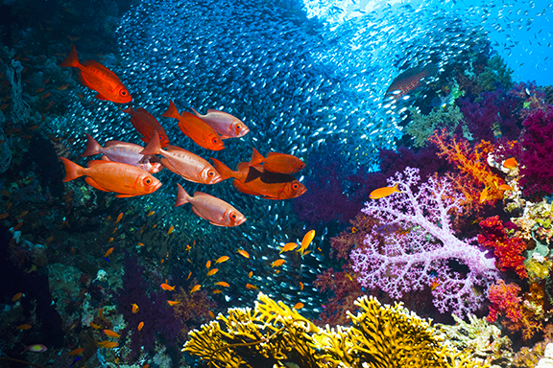

Figure 1. [Include all figures in their own section, following references (and footnotes and tables, if applicable). Include a numbered caption for each figure. Use the Table/Figure style for easy spacing between figure and caption.]

For more information about all elements of APA formatting, please consult the APA Style Manual, 6th Edition.